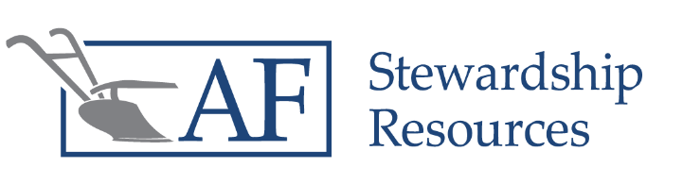

Budgeting Seminar
This free seminar focuses on basic Biblical and financial principles to help you honor the Lord with your finances

Budgeting Seminar
Do you know where you are financially? Do you wonder where your money goes? Are you frustrated in your marriage because of money? In this seminar, we will walk through some simple steps to creating your own family budget. A family budget can help couples communicate about their vision for finances, be better stewards of God-given resources, and show where your treasure and heart really are.

Quarryville, PA
Tuesday, February 23, 2021
6:30- 9:00 PM
Hoffman Building (At the Solanco Fairgrounds)
172 South Lime Street, Quarryville, PA 17566

There is no cost for the seminar, but we would appreciate it if you can register by February 16. This helps us make sure we have adequate seating and handouts available. Snack will be served, and resource materials will be provided free of charge.
To reserve your seats, please call (570) 468-1268 and leave a message, or email seminars@afweb.org

Elmer Stoltzfus: 717-271-4296
Levi Esh: 717-548-2291
John David Zook: 717-442-3191
Sponsored by Nickel Mines Business Owners Group:
For more information, please contact one of the local committee representatives:
Elmer Stoltzfus: 717-271-4296
Levi Esh: 717-548-2291
John David Zook: 717-442-3191
Levi Esh: 717-529-2291
John David Zook: 717-442-3191

